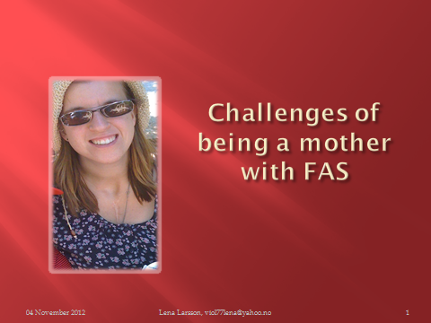
My name is Lena. My mother drank alcohol until she was four month pregnant and I have FAS.

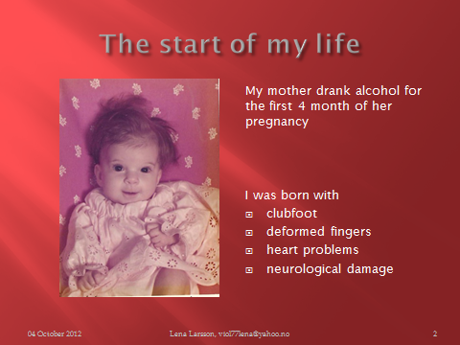
I was born with lifelong damages on my body and on my brain. I was diagnosed when I was a baby but no one ever talked to me about this. I was not aware of FAS until a few years ago.
I was born with heart problems that needed several surgeries, clubfoot, and malformations of fingers, just to mention some of the damages on my body.
The damages on my brain cause learning disabilities, problems with math and grammar and many other things that I struggle with every single day.
When I was one and a half years old I was taken from my mother and shortly after placed in a foster home in Sweden where I grow up.

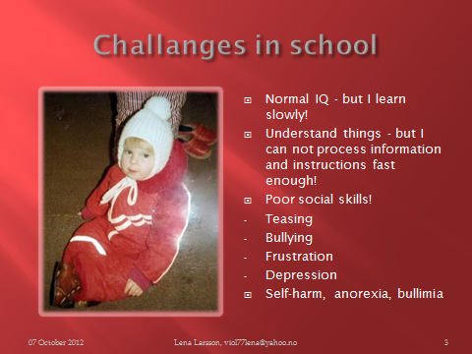
I had normal IQ and went to normal school but I had large problems with learning, attention and to focus in class.
All along school I struggle with the social life. I didn’t understand the social codes, I couldn’t make friends and I always felt as an outsider. I was often teased and bullied. It made me frustrated and sad many times and I got depressed.
In secondary school all the bullying, depression and frustration lead to self-harming and for many years I suffered from anorexia and bulimia.
In spite of the trouble I had in school I finally managed to get an education and I became a nursing assistant.
I also tried some jobs - but it just didn´t work.
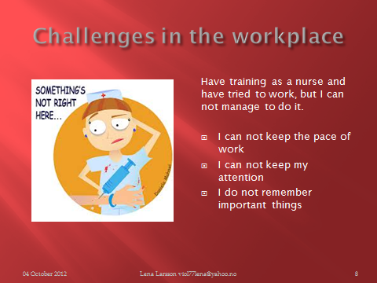

My work mates had too high expectations on me and I couldn’t live up to them. Even if I understood what to do I reacted too slowly. I couldn’t keep attention, I forgot things and I messed things up.

My poor social skills have led me into a lot of trouble. I find it hard to judge people and I'm probably a bit naive. I want to believe that all people are good, but they are not.
My diet is free from gluten, milk and soy. It helps me getting more energy and also not losing my temper so easily.

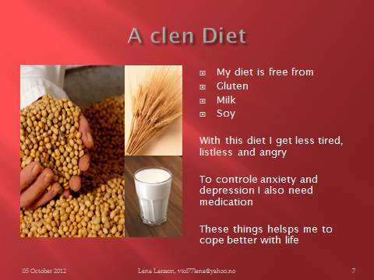
But, my life is not only failures! I have managed a lot in life and I have overcome many challenges. I’m a fighter!
The biggest joy – and challenge! - of my life is my beautiful nine year old son!
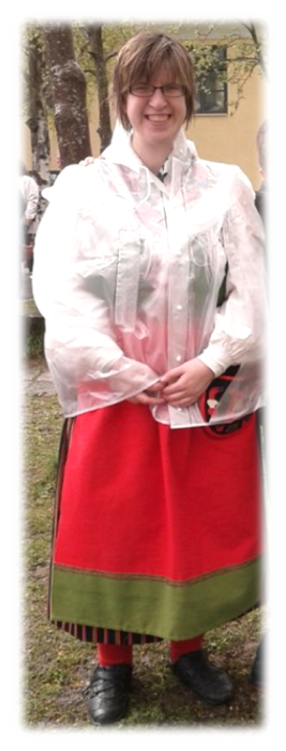

I am a single mother. Being a single parent is not easy for anyone and to be a single parent when you have FAS is tuff! For example; helping my son with his homework is difficult. Even if I understand what he is supposed to do I cannot explain it to him.
A growing boy also needs parenting and limits. It’s hard for me to set the right limits - and to stick to them.
To manage social every-day life with birthday parties, contacts with other parents and such things in is also a challenge.
To manage to be a single parent with FAS I’m in need of help. I go to parent education to learn how to cope and set limits. We also have a support family. That’s a relief for me.
To manage a house hold is also a big challenge!

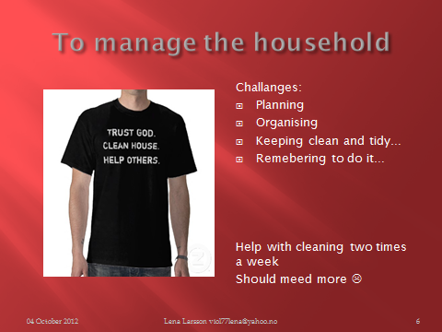

There are so many things that have to be planned. And so many things to be done and remembered! I get help from the community with cleaning two times a week but I should also need help with other things. For example more personal assistance with things like planning birthdays, organising papers, tidy up in cupboards and drawers and so on.
I get a lot of help from my church. I have converted to Catholic Church and my faith in God helps me.
Two times I have been on a pilgrim journey to Medjugorje in Bosnia.
These journeys have changed me very much and have given me joy of life! Thank you for listening and God bless you all!
